THE CICADAS ARE A COMING TO A NEIGHBORHOOD NEAR YOU!
By
Fredric Miller, Ph.D.
Senior Scientist – Entomology
The Morton Arboretum, Lisle, Illinois
Fmento84@gmail.com

The spring of 2024 will be a banner year for the periodical cicada with both the 13 and 17-year broods emerging throughout most of Illinois. With the exception of a few counties in extreme southern Illinois, the central portion (Springfield and south) will welcome the 13- year periodical cicada (Brood XIX) and areas north of Springfield will experience Brood XIII. Mathematically, it is a very rare event for both 13 and 17- year broods to emerge in the same year (see Figures 1A and B). In fact, the last time these two broods co-emerged (i.e. every 221 years) in Illinois, was in 1803 when Thomas Jefferson bought the Louisiana Purchase from France. I can tell you, having personally experienced the co-emergence in 1998 of the Missouri Broods IV (17 year) and Brood XIX (13 year), it was quite noisy.

What can we do to mitigate or prevent ovipositional damage to our younger and more vulnerable woody plants while at the same time enjoying this unique biological and ecological event? Here are some practical best management practices (BMPs) for homeowners, and members of the forestry, orchard, and green industries:

- First and foremost, enjoy the event as it will only last for a few weeks and will be at least 13 years before another emergence
- If possible, avoid 2024 spring plantings of very young trees and whips that are approximately less than two inches in diameter/caliper. Consider waiting until after adult activity has ceased and/or fall to plant
- If you have a limited number of susceptible plants, cover them with fine netting and make sure to gather the netting around the trunk and as near to the ground as possible. Once the emergence event is over, be sure to remove the netting
- Application of a systemic insecticide may help in reducing damage to susceptible plants, but you will need to apply the chemical well in advance of the cicada emergence in order it to be taken up by the plant. If you are in a drought situation, like in spring-summer, 2023, you may have to water plants in advance to insure good uptake.
- Studies have shown that application of contact insecticides has not shown to be effective and is not practical for large scale operations, and can be harmful to beneficials leading to insect and mite outbreak unrelated to the cicada emergence
- Mature and health trees will show some terminal branch flagging later in the season (i.e. August), but will only result in some “natural pruning” and is not harmful to the plant
The periodical cicada Illinois Brood XIII consists of three species, Magicicada septendecim, M. cassini, and M. septendecula and Brood XIX, also known as the Great Southern Brood is made up of four different species, M. tredecim, M. neotredecim, M. tredecassini, and M. tredecula.
There are both annual cicadas and periodical cicadas. While both groups spend most of their life cycle underground, the adult annual cicada is active in late summer (i.e. July and August) while “periodicals” emerge in late spring and early summer (i.e. May and early June). As their name implies, annuals emerge every year. Periodical cicadas are only found east of the Rocky Mountains (Figure 1A).

Immature and adult periodical cicadas have a piercing-sucking mouthparts that are used for extracting plant sap from fine roots, and twigs and branches. The adult cicadas feed very little with most of the plant damage resulting from the females using their saw-like ovipositors to lay eggs in small twigs and branches. The nymphs feed for 13 to 17 years, depending on the brood; 13-year life cycles in the southern states and 17-year cycles farther north (Figures 3 and 4).

Upon emergence from the soil, the adult cicadas briefly feed on a variety of woody plants. Feeding damage from the adults is minimal at most, but once mating has been completed, the adult females , with their saw-like ovipositor, will begin cutting longitudinal slits in the twigs and branches of woody plants and will lay up to 20 eggs in each of these “egg nests” (Figures 4, 5, and 6). An adult female can lay up to 600 eggs during her lifetime (Brown and Zuefle, 2009). After about 6-10 weeks, the newly hatched nymphs will drop to the soil, burrow in and then begin feeding on the fine roots of the host plant spending the next 13 or 17 years underground (Brown and Zuefle, 2009) (Figures 4, 5, and 6).

While most cicadas are considered “generalists” (i.e. broad host range), like all living creatures, they have their preferred host plants for egg laying including apple (Malus spp.), hickory (Carya spp.), maple (Acer spp.), and oaks (Quercus spp.) (Brown and Zuefle, 2009). Members of the birch (Betulaceae), dogwood (Cornaceae), walnut (Juglandaceae), willow (Salicaceae), linden (Tiliaceae), and elm (Ulmaceae) plant families may also be attacked. Additional hosts may include introduced exotic ornamentals such as Rosa spp. Cotoneaster spp., Forsythia spp., Ginkgo biloba, Pyrus spp., and Syringa spp (Brown and Zuefle, 2009). However, plants with resinous sap (i.e. conifers, Rhus spp) gum production by Prunus spp., and persimmon (Diospyros virginiana) are typically not preferred for egg laying since the sap tends to prevent egg hatch (Brown and Zuefle, 2009) and escape by the nymphs. For a more comprehensive list of host plants refer to the following references (Forsythe , 1975, White, 1980, Miller, 1997, Miller and Crowley, 1998, Cook et al., 2001).

While adult ovipositional damage on mature trees and shrubs is usually no more than “natural pruning”, very young woody plants and whips can be damaged and even killed due to the females ovipositing on the young stems causing wounds that may lead to breakage of the stem, top kill, and also provide entry for canker causing fungi and wood-boring insect pests (Figures 6 and 7). A number of studies have found that there appears to be a minimum and a maximum twig/branch diameter that is preferred for oviposition ranging from 3 to 11 mm (1/8 to 7/16 in.) (White, 1980, Karban, 1982, Miller, 1997, Miller and Crowley, 1998). Other forms of cicada damage include a reduction in overall plant health and depletion of energy reserves resulting in decreased flower and fruit production where heavy populations of nymphs feed on the fine roots of trees and shrubs. Ovipositional wounds may allow for entry of canker-causing pathogens and wood-boring insect pests.

Host preference of the periodical cicada is not fully understood. Preference for native versus exotic plants, leaf arrangement, resin levels, light, and plant architecture may play a role in determining which plants are utilized for egg laying. For example, in a study in Delaware by Brown and Zuefle (2009) they found that non-native plants tended to be more favored that native plants. In contrast, in a study by Miller and Crowley (1998) at the Morton Arboretum, Lisle, Illinois, they found no significant differences in plant damage between natives and non-natives. Regarding plant architecture, Brown and Zuefle ((2009), in examining 428 plants, found that the probability of oviposition increased with increasing branch/twig diameter and plant structure. In other words, plants with “bushy”, dense growth habits or with numerous long branches had higher rates of oviposition, but fewer wounds per stem length compared with plants with a less dense and a more upright growth habit. Their results suggest that “bushy” plants or plants with many stems may impeded cicada oviposition, and also may dilute the number of wounds.

In most situations, conifers are rarely attacked probably due to arrangement of needles on the twigs which impedes the ability of the female to oviposit and resin which can trap and kill eggs preventing egg hatch of young nymphs. This may also be true for gum producing plants such as Prunus spp. (i.e. cherries, peaches, plums) (White, 1980, Karban, 1983, Cook et al., 2001). Miller and Crowley (1998) found that conifers and evergreens differed in their susceptibility to ovipositional damage. For example, plants with needles or leaf scales that did not completely encircle the twig and twigs that were less stout and flexible (i.e. hemlock, juniper, arborvitae, yew) did experience some damage as compared with conifers with stouter twigs and needles that completely encircled the branch (i.e. pines, spruces, firs). White (1980) found that black walnut (J. nigra), Osage orange (Maclura pomifera) were rarely used for egg laying due to their spongy pith which contributed to egg desiccation. Stem diameter is also a critical factor. Plants, such as tree of heaven (Ailanthus altissima), Kentucky coffee tree (Gymnocladrus dioicus), and sumac (Rhus spp.), which had thick, stout stems near or exceeding 10 mm (3/8 in.) in diameter were not attacked. Interestingly, however, female cicadas did attempt to oviposit in the leaf rachis of G. dioicus (diameter =4 mm or 5/32 in.) which is within the range of stem diameters for egg laying.

What about nymphal feeding on plant roots? In a study by Speer et al. (2010), they found no effect from root parasitism (feeding) by cicada nymphs prior to emergence when feeding on five Midwestern Forest trees, Acer saccharum, Fraxinus americana, Quercus palustris, Q. velutina and Sassafras albidum, but three of the species chronologies showed a significant reduction in growth the year of or the year after the emergence year, and three chronologies showed an increase in growth five years following the cicada emergence event.

Another interesting phenomenon is that cicadas may use sunlight (solar) as a cue in selecting host plants. In field experiments by Yang (2006) it was discovered that female cicadas use the local light environment of host trees during the summer of emergence to select long-term host trees. Light environments may also influence oviposition microsite selection within hosts, suggesting a potential behavioral mechanism for associating solar cues with host trees.

Once ovipositional damage has occurred how long is it before the plants “heal up” (i.e. callus over) the wounds? In two studies by Miller (1997) and Miller and Crowley (1998), examining 140 exotic and native woody plant genera, and 14 different urban forest parkway tree taxa, they found that most plants calloused (healed) over their wounds within 1-2 years after a cicada emergence; exceptions being alder (Alnus spp.), black walnut (Juglans sp.), redbud (Cercis sp.), lilac (Syringa spp), lindens (Tilia spp.), honey locust (Gleditsia triacanthos), northern red oak (Q. rubra), hackberry (Celtis occidentalis), ‘Redmond linden” (Tilia americana ‘Redmond’), and Littleleaf linden (T. cordata) which took at least three years to heal. Of course, plant health, growing conditions, and level of injury all affect wound healing rates. In spite of heavy ovipositional damage and delayed wound healing on susceptible plants, no significant canker-causing pathogens or insect pest issues were observed on these same woody landscape plants, and urban parkway tree taxa.

What about protecting vulnerable plants with insecticides? Miller and Crowley (1998) found that applications of non-systemic (i.e. contact) insecticides were not effective and adult females were not deterred from landing on host plants. In a more recent study, Ahern, et al. (2005) compared the efficacy of a neonicotinoid systemic insecticide, imidacloprid, and a nonchemical control measure, netting, to reduce cicada injury. They determined that netted trees sustained very little injury, whereas unprotected trees were heavily damaged. Fewer egg nests, scars, and flags were observed on trees treated with imidacloprid compared with unprotected trees; however, the hatching of cicada eggs was unaffected by imidacloprid.

REFERENCES CITED AND RECOMMENDED READINGS
Ahern, R.G., S.D. Frank, and M.J. Raupp. 2005. Comparison of exclusion and imidacloprid for reduction of oviposition damage to young trees by periodical cicadas (Hemiptera: Cicadidae). Journal of Economic Entomology 98(6): 2133-2136

Brown, W. and M.E. Zuefle. 2009. Does the periodical cicada, Magicicada septendecim, prefer to oviposit on native or exotic plant species? Ecological Entomology 34: 346-355.

Cook, W.M., R.D. Holt, and J. Yao. 2001. Spatial variability in oviposition damage by periodical cicadas in a fragmented landscape. Oecologia , 127: 51-61 .

Cook , W.M. and R.D. Holt. 2002. Periodical cicada (Magicicada cassini) ovipositional damage: visually impressive yet dynamically irrelevant. American Midland Naturalist, 147: 124 – 224 .

Forsyth, H.Y. 1975. Ovipositional Host Plants of 17-Y ear Cicadas. Ohio Agricultural Research and Development Center Research Circular #210. 20 pp.

Karban, R. 1982. Experimental removal of 17-year cicada nymphs and growth of host apple trees. Journal of the New York Entomological Society 90: 74-81 .

Karban , R. 1983. Induced responses of cherry trees to periodical cicada oviposition. Oecologia , 59: 226 – 231 .

Miller, F. 1997. Effects and control of periodical cicada, Magicicada septendecim and Magicicada cassini oviposition injury on urban forest trees. J. of Arboriculture. 23(6): 225-232.

Miller, F. and W. Crowley. 1998. Effects of periodical cicada (Homoptera: Cicadidae: Magicicada septendecim and Magicicada cassini) ovipositional injury on woody plants. J. of Arboriculture 24(5): 248-253.

Smith , F.F. & Linderman , R.G. 1974. Damage to ornamental trees and shrubs resulting from oviposition by periodical cicadas. Environmental Entomology, 3: 725 – 732 .

Speer, J.H., K. Clay, G. Bishop, and M. Creech. 2010. The effect of periodical cicadas on growth of five tree species in Midwestern deciduous forests. The American Midland Naturalist, 164(2): 173-186
White , J. and C.E. Strehl. 1978. Xylem feeding by periodical cicada nymphs on tree roots. Ecological Entomology, 3: 323-327.

White, J. 1980. Resource partitioning by ovipositing cicadas. American Naturalist 115: 1-28 .

White , J . 1981. Flagging: host defenses versus oviposition strategies in periodical cicadas (Magicicada spp., Cicadidae, Homoptera). Canadian Entomologist 113: 727-738 .

White , J., M. Lloyd, and R. Karban. 1982. Why don’t periodical cicadas normally live in coniferous forests? Environmental Entomology, 11: 475-482 .

Yang , L.H . 2006. Periodical cicadas use light for oviposition site selection. Proceedings of the Royal Society B, 273: 2993 – 3000 .

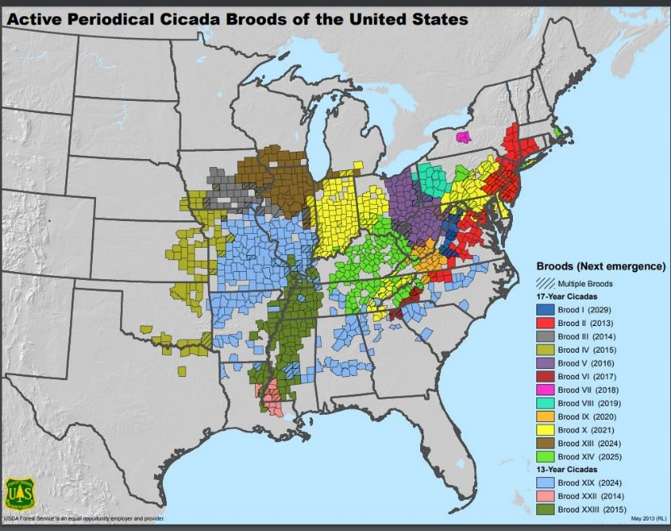

Figure 1A: Active Midwest periodical cicada broods

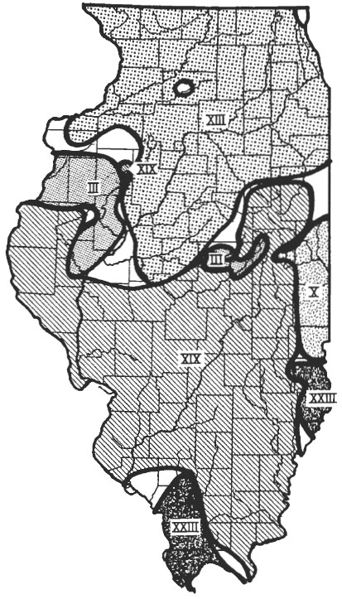
Figure 1B: Active Illinois periodical cicada broods

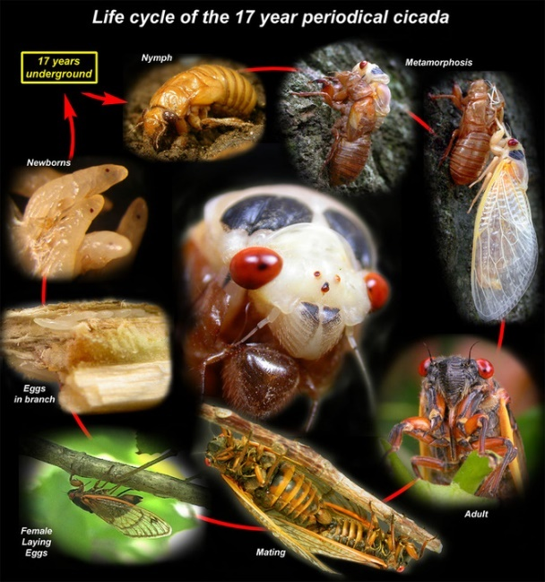
Figure 2: Life cycle of the 17-year periodical cicada

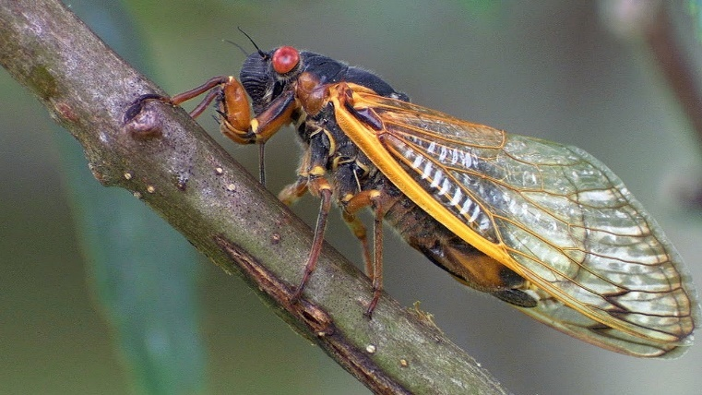

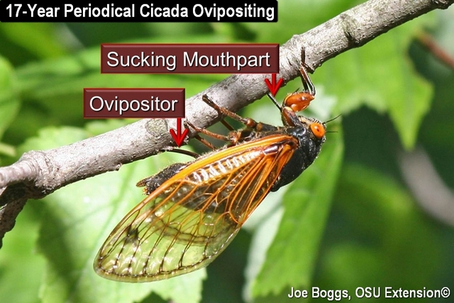
Figure 3: Adult periodical cicada

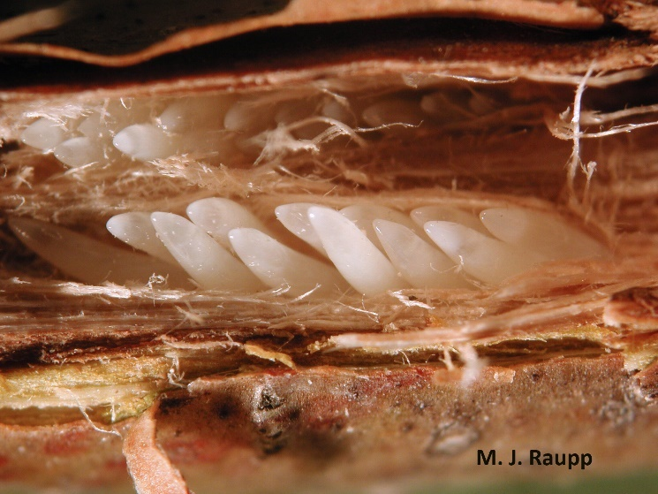
Figure 4: Periodical cicada egg nest

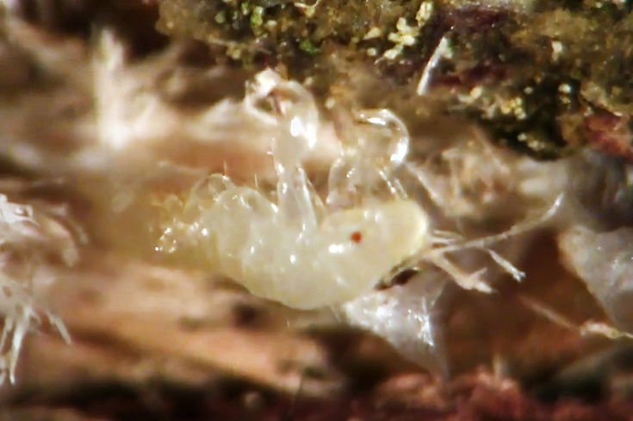
Figure 5: Young periodical cicada nymph

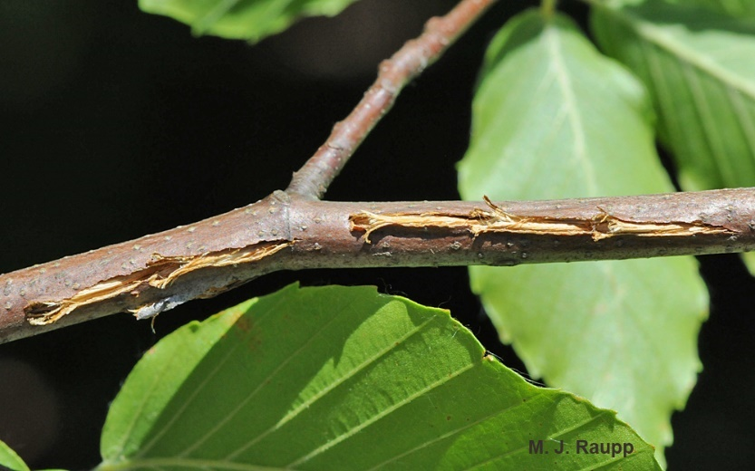
Figure 6: Ovipositional damage to woody twigs and branches
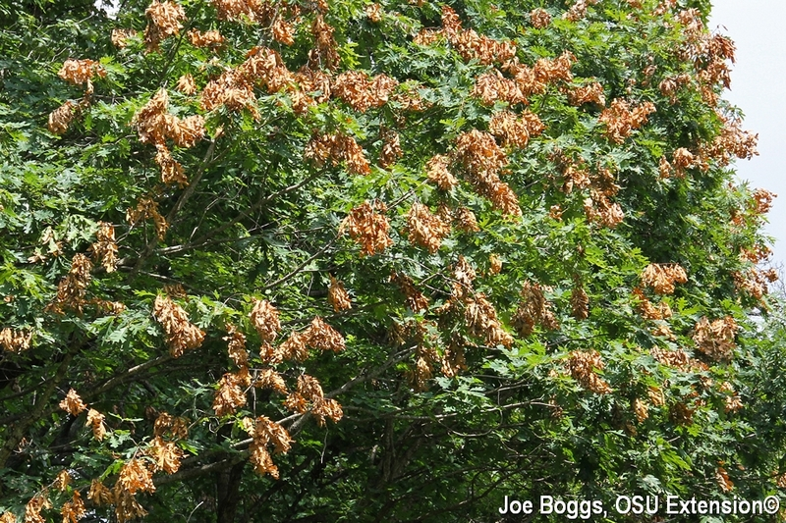

Figure 7: Late season flagging due to egg laying by adult female periodical cicadas

