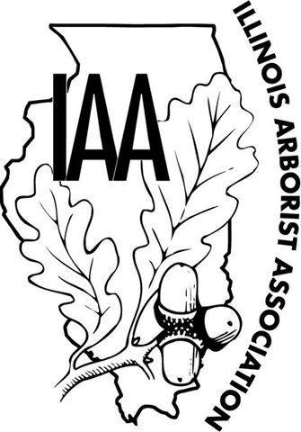

IAA BOARD OF DIRECTORS MISSION STATEMENT

On behalf of the Illinois Arborist Association (IAA) and the Board of Directors, we welcome you to our organization and wish you every success. We believe that each member/director can contribute directly to the IAA mission.

MISSION STATEMENT

“Foster interest, establish standards, exchange professional ideas and pursue scientific research in arboriculture.

The network of individuals that works in conjunction with IAA, such as commercial arborists, municipal arborists, utility arborists, researchers and students, is a passionate group of individuals working in unison to increase statewide awareness of the benefits of trees and the value of professional tree care.

This manual is designed to acquaint you with the IAA and provide you with information about our governance structure, policies, procedures, and various tools and resources available to assist you in your role as a director.

We hope that your experience as a board member will be challenging, enjoyable, and rewarding.

Sincerely,
April Toney

